Name _____________________________________ Date _________________ Period _____

BOCES Science Laboratory Investigation
CILANTRO GENETICS
Background Information

Many people like or dislike many different foods, but they rarely stop to consider the reason. And by reason, we are not referring to something such as “the taste is bitter” or “it tastes like burning hair.” What is the real reason that your brain interprets any given taste as “bad” or “good?” For that matter, what makes people like one color over the other? Here we have some interesting points.
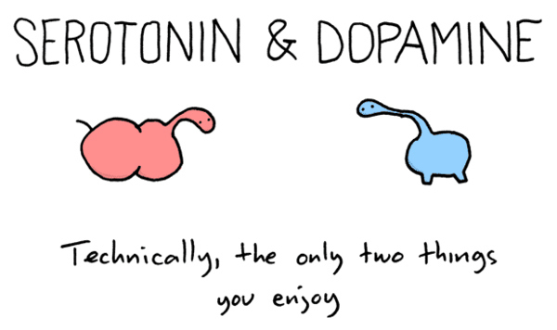
Consider color for a moment. Colors are different wavelengths of light. These wavelengths enter our eyes and strike cells in our retina that contain chemicals that react to light. These cells in turn activate a nerve that sends a message to our brains that says “hey, that thing over there, it’s blue.” But these cells don’t tell our brain anything about the “goodness” of the color; that is, they don’t indicate whether it is pleasing or not. So higher parts of our brain can receive this blue signal and, based on the presence or absence of certain chemicals called neurotransmitters, can determine if we like it or not. The amount and location of these neurotransmitters is determined mostly by your DNA.
Of course, there are other things that can influence these neurotransmitters. Many preferences are based on our interactions with society. As an example with colors, many parents choose to paint a nursery blue if they are aware that their fetus is male, and pink if it’s female. We condition females to like pink, and males to like blue. This conditioning can alter the presence of neurotransmitters in our brains, even if our DNA indicates something to the contrary.
The same can be true with taste. Our like or dislike of many foods is encoded in our genes, but that can be altered by our environment, too. Many people claim that Brussels sprouts are bitter and therefore they don’t like them. However, people who have eaten Brussels sprouts from a very young age may grow to like them, simply because of chemical changes in their brains through environmental stimuli.
This is all well and good, but why might some people have a different amount of chemicals in their brains than others? The obvious answer is either their genes or their environment. In nature , there always has to be a reason for a difference, and that reason usually comes down to an evolutionary benefit. If a particular gene is beneficial to an organism, then it is passed on to more offspring and spreads in the population. So if many people find a particular food unpleasant, then there must be some very good reason for it.
Cilantro is one of those foods and, for reasons that are not entirely clear, several scientists have chosen to look at the genetic reasoning behind the aversion to or love of the taste of cilantro. It turns out that there are several genes that are linked to the enjoyment of or distaste for cilantro. Today we’re going to look at the connection between genetics and taste.
Purpose

The purpose of this investigation is to determine if there is a connection between a person’s genotype and their dislike of cilantro. We will also learn about pedigrees and other ways to map a gene as it moves from generation to generation. We will touch on the relationship of the prevalence of a given gene in a population to its evolutionary benefit.

Materials

Fresh cilantro PTC Paper
PENCIL

Procedure
- Obtain a small amount of fresh cilantro. Place it in your mouth and chew to grind it and release the compounds in the leaves.
- Rate your experience on the following scale:
1 – Dislike extremely
2 – Dislike very much
3 – Dislike moderately
4 – Dislike slightly
My cilantro rating _____________
5 – Neither like nor dislike
6 – Like slightly
7 – Like moderately
8 – Like very much
9 – Like extremely

- Prepare a histogram of the data for the class on the graph provided below. BE SURE to include all necessary labels!

- Taste a piece of PTC paper by placing it on your tongue and closing your mouth around it. When you are finished, discard it in the garbage can.

Analysis

QUESTION 1: Was there a correlation between the ability to taste PTC and cilantro preference for your data? If so, what was it?

QUESTION 2: Was there a correlation between the ability to taste PTC and cilantro preference for the class data? If so, what was it?

QUESTION 3: Why might it be beneficial to have hypersensitive taste receptors?

QUESTION 4: Dogs and other animals often have many more taste receptors than we do. Why might this be?

QUESTION 5: What experiment could you do to determine if DNA or culture/upbringing is more important in determining cilantro preference?

QUESTION 6: How might this information be useful to you when planning menus?

QUESTION 7: Do dried and fresh cilantro taste the same? What about cooked cilantro? Do you think that people who dislike fresh cilantro also dislike dried or cooked cilantro? Why or why not?

The graphs on this page are taken from a study by Lilli Katherine Mauer at the University of Toronto in 2011 entitled “Genetic Determinants of Cilantro Preference.” She determined that different ethocultural groups have different cilantro preferences, and that there are mutations in two genes that correlate with cilantro preference. The first is TAS2R1, a bitter taste receptor gene, and the second is OR4N5, an olfactory receptor gene. SNPs (Small Nucleotide Polymorphisms) in these genes confer a preference or distaste for cilantro. In the Caucasian population studied, there was a direct relationship between cilantro preference and the presence of particular SNPs. This relationship was not established for other ethnocultural groups.
Frequency of dislike across all geneotypes
South Asian
East Asian
Caucasian Data

