Name ______________________________________ Date _______________ Period ______

CTE Science Laboratory Investigation

INK CHROMOTOGRAPHY

Introduction

The word chromatography comes from the Greek “chromos” meaning color, and “graphy” meaning writing or picture. As such, what we are going to do today is make a colourfl picture, using simple inks and solvents.
The basic concept of chromatography is really quite simple. The ink in pens is usually only one colour, but it is made out of many different compounds, each a different colour. When all the compounds are added together, the desired ink color – be it black, blue, or any other – is achieved. We can separate the various compounds in ink by using a solvent. A solvent is usually very volatile, meaning that it becomes a vapor very easily, and can be either polar or non-polar. The two solvents that are most commonly used in ink chromatography are water and either ethyl or isopropyl alcohol.
This technique can be used in forensics to analyze the ink from notes or letters found at the crime scene. A small sample is taken, and the paper is dipped in the solvent. The solvent travels up the paper, carrying each compound a different distance, depending on how much the solvent is attracted to the compound. The result is a chromatogram, and can be compared to other chromatograms to be admitted as evidence.

Purpose

The purpose of this investigation is to acquaint you with the process of ink chromatography, and to explore other, more accurate means of detecting subtle differences in various substances that may be found at a crime scene.

Materials

Crime scene note PENCIL
Markers Distilled water
Ethanol Beakers
Wooden splint Tape

Procedure

1. Select one of the markers that was collected from the crime scene.
2. Make a mark on a piece of chromatography paper with the maker as indicated in figure 1. Make sure that the mark is above the bottom of the paper and allows space for the solvent.

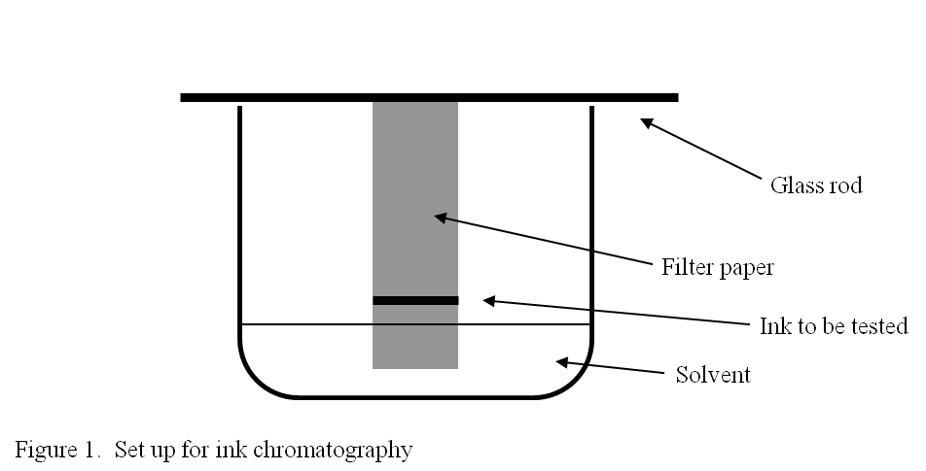

Figure 1. Chromotography setup.

3. Tape the paper to the wooden splint so that it hangs just above the bottom of the beaker.
4. Add solvent to the beaker and allow it to sit, undistrubed, until the solvent reaches near the top of the paper.
5. When the solvent reaches the top, remove your paper and allow it to dry. Compare it to the chromatogram of the crime scene note.
6. Attach your chromotogram in the space below.

Analysis

QUESTION1: What techniques did we use today that would be considered good forensic science?

QUESTION 2. What techniques did we use today that might have made our evidence inadmissible in court?

QUESTION 3. This technique is commonly used in forensic labs to analyze notes found at crime scenes. What other applications might it have in the field of forensics?

QUESTION 4. We often use chromatography in the bio lab to separate pigments from plant leaves or to determine the structure of other compounds, such as anthocyanins. How might this type of chromatography be helpful in a criminal investigation?

QUESTION 5. This process requires that the original note (a slice of evidence) be destroyed so that the test can be conducted. What should be done BEFORE ink chromatography to make sure that as much evidence as possible is preserved?

