Name _____________________________________ Date _________________ Period _____

CTE Science Laboratory Investigation
PROPERTIES OF GASOLINE
Introduction

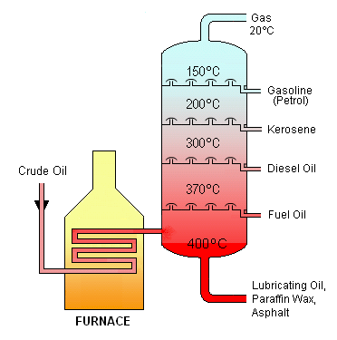
Gasoline is a mixture of hydrocarbons that are derived from crude oil. Oil is old, and is the result of millions of years of pressure and heat acting on ancient plant matter. So in a sense, oil is a renewable resource, if you have a few million years to wait for some dead plants to turn into it. To make gasoline, oil is refined. This is usually achieved by heating the oil in large furnaces to separate it out by density. The least dense components (with the lowest boiling points) float to the top while the densest ones (with the highest boiling points) sink to the bottom. Figure 1 shows a schematic of how the components of crude oil would separate.
Gasoline is one of the least dense parts, and is widely used because it has properties that are ideal for an internal combustion engine. The combustion in a cylinder of your car is a particular type of combustion reaction called deflagration. In a deflagration reaction, an ignition source (in our case, a spark plug) ignites one part of the gasoline, which then ignites another part, and another, and so on. The reaction proceeds at a speed less than the speed of sound. This can be contrasted with a detonation, in which the reaction spreads through the fuel at a speed greater than the speed of sound. This type of reaction is observed in explosives and some other types of fuels.
Figure 1. Schematic of a
gasoline refinery.
If the combustion of gasoline happens too quickly; that is, if the hot gasoline starts to ignite itself instead of being ignited from the spark plug, a condition known as spark knock results. Essentially, there is not a controlled, smooth deflagration of the gasoline, there is the combustion caused by the spark plug and caused by the gasoline igniting itself. This can be damaging to the engine and can reduce performance.
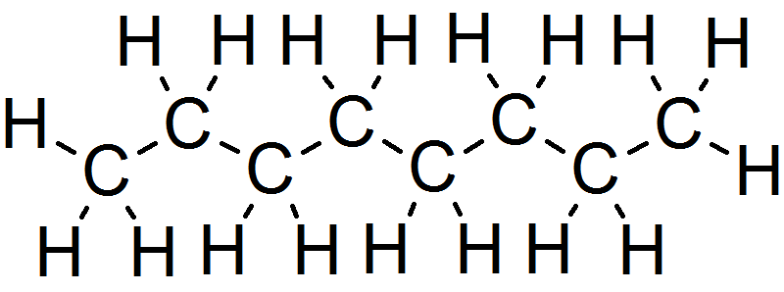
In the early 1900s, it was discovered that spark knock could be reduced or eliminated by adding tetraethyl lead to gasoline. Adding the compound increased the octane rating of the gasoline, but also put a lot of lead out into the environment, so it was phased out in the 1970s. Now, other hydrocarbons like octane, pictured in figure 2, are added to gasoline to reduce its tendency to self-ignite. If the gasoline is less likely to self-ignite, then it can be compressed more in the cylinder. This allows the creation of high-performance engines with higher compression ratios. It also allows better control of the combustion reaction.
Figure 2. Molecular formula of octane.
In the end, the additives and composition of gasoline determine its properties, and any change can be damaging to an engine or to its performance. With new environmental regulations and a changing climate, it’s important for us to consider the effects of ethanol, biodiesel and other fuels on current car engines.

Purpose

The purpose of this investigation is to help you better understand the concept of vapor pressure and how it relates to an automobile engine. We will also explore the idea of how to determine the composition of a particular mixture of chemicals and test to see if it is contaminated.

Materials

LabQuest Temperature probe
Pressure sensor Erlenmeyer flask
Laptop computer PENCIL
Alcohol samples Gasoline samples

Procedure

PART I – EVAPORATION TESTING

In this section, you will explore how different chemicals evaporate and identify what effects this might have on an engine.

- Obtain a LabQuest and temperature probe.
- Wrap a paper towel around the probe and secure it with a rubber band.
- Select a chemical to test and record it in table 1.
- Dip the paper-towel-covered probe in the chemical that you have chosen.
- Click “collect” to begin collecting data.
- ait for the temperature to equilibrate, and record the initial temperature of the liquid in table 1.
- Remove the temperature probe and set it on the edge of the table (use tape to secure it, if necessary) so that the probe is hanging off the edge of the table.
- When the temperature reaches the lowest point and begins to increase, stop collecting data.
- Record the final temperature in table 1.
- Repeat the process for at least one other chemical.

Chemical | Initial Temperature | Final Temperature | Temperature Difference
Table 1. Data for evaporation testing.

QUESTION 1: It turns out that molecules that are larger (that is, that have a higher molecular weight) evaporate more slowly than molecules that are smaller. Based on your observations of your two chemicals, which one is larger and which one is smaller?

QUESTION 2: The forces holding the molecules together can also determine how fast they evaporate. All alcohols have an oxygen atom exposed that can bind to a hydrogen atom on another alcohol. Octane has no oxygen atoms, and cannot form a bond with other octane molecules. Given this information, do you think that octane or an alcohol like ethanol has quicker evaporation rate? Why?

QUESTION 3: Many oil companies now add up to 10% ethanol to their gasoline mixtures. What effect might this have on a car?

QUESTION 4: How could you use this information to determine if gasoline has more or less than 10% ethanol?

PART II – VAPOR PRESSURE TESTING

In this section you will determine the vapor pressure of various chemicals and observe how this may affect the performance of a modern automobile.

- Create a water bath by filling a 1 L beaker with water. Allow the water to come to room temperature.
- Place a temperature probe in the beaker.
- Put the rubber stopper assembly in the 125 mL flask, and place the flask in the beaker.
- Make sure that the valve on the stopper is open, and record the ambient atmospheric pressure in table 2.
- Close the valve on the stopper.
- Using the syringe, draw up 3 mL of a chemical. Record the chemical that you use in table 2. WITHOUT OPENING THE VALVE, screw the syringe onto the valve on the stopper.
- Open the valve, and quickly squirt all of the chemical into the flask. Quickly return the plunger of the syringe to the 3 mL mark.
- Close the valve and remove the syringe.
- Wait until the pressure reading equilibrates, then record your data in table 2.
- Repeat the procedure with at least one other chemical.

Chemical | Temperature | Initial Pressure | Final Pressure | Pressure Difference
Table 2. Data for vapor pressure testing.

QUESTION 5: Which substance that you tested had the higher vapor pressure (pressure difference from table 2)?

QUESTION 6: In general, smaller molecules evaporate more easily, and thus will have a higher vapor pressure. Which molecule that you tested do you think is the largest? The smallest?

QUESTION 7: Boiling is defined as the point at which the vapor pressure of a liquid reaches the ambient pressure of the air around it. Raising the temperature of water will cause its vapor pressure to rise. When it reaches the ambient pressure, it will begin to turn into a gas. Do you think it is possible to boil water without heating it? If so, what would you do?

QUESTION 8: Pre-packaged baking mixes often contain directions for high-altitude cooking. Why would one have to change a recepie at a higher altitude where there is less pressure?

QUESTION 9: Why do many companies change the composition of their gasoline in the summer and winter?

QUESTION 10: What could happen if the vapor pressure of gasoline is too close to the ambient atmospheric pressure?

PART III – GASOLINE TESTING

In this part, you will test a sample of gasoline to attempt to determine its composition.

- Obtain a sample of gasoline and, using the procedures above, determine its evaporation rate and vapor pressure.
- Record any observations or measurements that you need to make in the space below. It is highly recommended that you construct a data table modeled after the ones earlier in the lab.

QUESTION 11: Do you think gasoline has stronger or weaker attractions between its molecules as compared to the other chemicals you tested? Why?

QUESTION 12: Do you think gasoline contains molecules that are larger or smaller than the other chemicals you tested? Why?

